**Algorithm Explained**

I’m reading the input through a CSV (Comma Separated Value) file. When the input read is a birth year, the subsequent cell in the year vector is incremented, and when the input read is a death year, the subsequent cell in the year vector is decremented. So by this method the number of people alive in a year is the sum of all the values of the previous years and this year in the vector.

For e.g. if we are given 5 people with birth and death years: -

1. 1920 to 1925
2. 1922 to 1924
3. 1925 to 1928
4. 1927 to 1929
5. 1920 to 1923

This is how the year vector would look after the file is read using our algorithm

|  |  |  |  |  |  |  |  |  |  |
| --- | --- | --- | --- | --- | --- | --- | --- | --- | --- |
| 2 | 0 | 1 | -1 | -1 | 0 | 0 | 1 | -1 | -1 |

1920 1921 1922 1923 1924 1925 1926 1927 1928 1929

As we can see there were 2 people born and are alive in 1920 (1 & 5). But 1921 shows that the number of people alive are 0. But this is false as the 2 people alive in 1920 are alive in 1921 and their deaths have been denoted by -1’s in 1925 and 1923. Hence the number of people alive in 1921 is the value of all cells in the vector before 1921 and 1921 i.e. 2 + 0 = 2. Similarly for 1922 it will be 2 + 0 + 1 = 3. So as we can see each cell’s value is added into the next cell or number of people alive in a year is the sum of its cell’s value and the previous cell’s value.

So after applying this to the given vector we get the following result.

|  |  |  |  |  |  |  |  |  |  |
| --- | --- | --- | --- | --- | --- | --- | --- | --- | --- |
| 2 | 2 | 3 | 2 | 1 | 1 | 1 | 2 | 1 | 0 |

1920 1921 1922 1923 1924 1925 1926 1927 1928 1929

Hence 1922 becomes the year when maximum number of people (3) were alive.

**Sample Input**

**Sample Output**

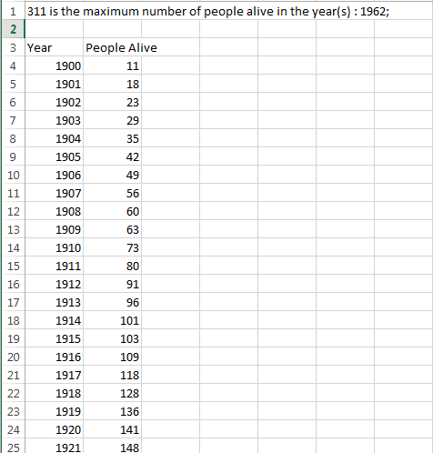 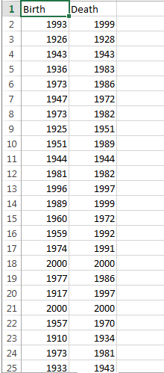

File Output

Console Output

